**Chitkara University**

Located 30 kms from **Chandigarh**, Chitkara University offers a world of learning that will help you reach your goals. Choose from our varied industry endorsed programs. Learn from an outstanding faculty at our state-of-the-art teaching facilities. Explore unlimited opportunities to get placed with one of the *1500+* *campus recruiters* *and meet other students with dreams as big as yours.*

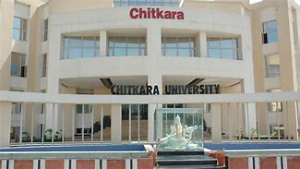

**Courses:**

|  |  |  |  |
| --- | --- | --- | --- |
| **Engineering** | **Science** | **Commerce** | **Others** |
| B-Tech in CSE | Bsc in Maths | BBA | Deploma in IT |
| B-Tech in ME | Bsc in chemistry | MBA in Marketing | Deploma in civil |
| B-Tech in CHE | Bsc in Physics | MBA in Finance | NCC |

**Others Service:**

1. Bus
2. Career counselling
3. Sports
4. Hostels
5. Restaurants

**Enquery Form:**

# Name:

Enter Your Name

# District:

Enter Your District

# State:

Enter Your State

# Age:

Enter Your age

# DOB:

Enter Your dob

# Email:

Enter Your Email

# Gender: **Male**

**Female**

Your special Enquery

SUBMIT